Prof. UWr., dr hab. Urszula Komarnicka
Department of Biological and Medical Chemistry
urszula.komarnicka2@uwr.edu.pl
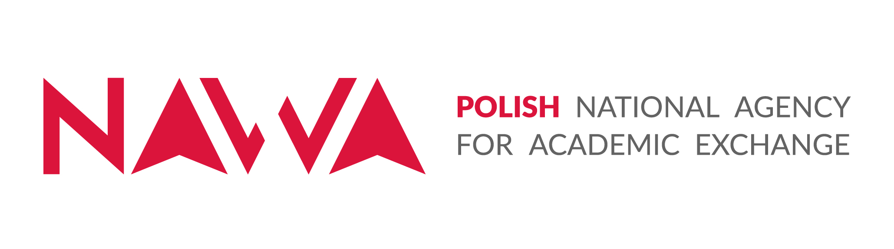
Call for NAWA Mobility Scholarships for Research Stays at the Faculty of Chemistry, University of Wrocław, Poland

Strategic Partnerships – 2024 no BPI/PST/2024/1/00028, title: „International collaboration in studies on the stability and degradation dynamics of ferroptosis-inducing compounds.

PI: prof. UWr., dr hab. Urszula Komarnicka

Number of scholarships available in this edition: 3 - dedicated to collaborators and co-workers of Prof. Debbie Crans (Colorado State University), Prof. Mark Brown (Mount Marty University, South Dakota), and Prof. Valentina Gandin (University of Padova). Each scholarship covers a maximum 120-day research stay at the Faculty of Chemistry, University of Wrocław, Poland.

Employment Conditions
Each internship will last maximum 120 days (4 months), and the project covers travel and living expenses during this period. The daily rates for accommodation and travel are specified in detail in the NAWA 2025 Beneficiary Handbook. The timing of the internship will be agreed upon with the scholarship holders, but it must be completed by October 2027.

Project Objectives: The project aims to build long‑term research collaboration between the University of Wrocław and international Strategic Partners, strengthening the University’s internationalization and interdisciplinary research capacity. The Partnership focuses on understanding the stability, degradation, and anticancer activity of organometallic phosphine compounds, especially their role in inducing ferroptosis. The work includes studying compound stability in biological media, evaluating anticancer effects of complexes and their degradation products, and analyzing their mechanisms of action. The project will expand UWr’s international network, support mobility of students and staff, and enhance the University’s scientific visibility and competitiveness.

Research Tasks
- Investigation of the stability of phosphine coordination compounds using various methods, including NMR, MS, and electronic emission and absorption spectroscopy,
- Characterization of the degradation products of the studied systems using various methods, including NMR, MS, and electronic emission and absorption spectroscopy,
- Stability studies in biological media using various methods, including NMR, MS, and electronic emission and absorption spectroscopy,
- Examination of interactions between coordination compounds and their degradation products with selected biomolecules using various methods, including NMR, MS, and electronic emission and absorption spectroscopy,
- Evaluation of anticancer activity using cancer cell line models and analysis of mechanisms of action.

Candidate Requirements
- Interest in phosphines and the inorganic chemistry of transition metals, particularly compounds with biological activity (V, Cu, Ir, Ru),
- Experience in the synthesis and purification coordination compounds (knowledge of techniques for working under an oxygen-free atmosphere),
- Familiarity with physicochemical techniques necessary for characterizing new compounds (NMR, MS, UV-Vis, fluorescence, cyclic voltammetry),
- Experience in studying interactions of compounds with biomolecules and speciation using methods such as NMR, MS, and UV-Vis,
- Experience in computational techniques for studying small molecule properties such as DFT and MM,
- Experience in x-ray,
- Proven experience in culturing, maintaining, and performing experiments using established cell lines.
- Advanced English proficiency, enabling report writing, publication preparation, participation in international research internships, and attendance at international conferences,
- Availability and high motivation to work,
- Ability to work in a dynamic research team.

Application
- CV (scientific achievements, research experience, scientific publications, oral and poster presentations at conferences, internships, training, participation in research projects, awards, distinctions) and obligatorily the clause: “I consent under Articles 4 and 7 of the GDPR, i.e., Regulation (EU) 2016/679 of the European Parliament and of the Council of 27 April 2016 on the protection of natural persons with regard to the processing of personal data and on the free movement of such data, and repealing Directive 95/46/EC (General Data Protection Regulation) (OJ EU L of 4.05.2016, pp. 1–88), to the processing of my personal data by the University of Wrocław, pl. Uniwersytecki 1, 50-137 Wrocław, for the purpose of recruitment for employment at the University of Wrocław. I am aware that the consent given may be withdrawn at any time in a manner adequate to its granting.”
- Cover letter.

Applications should be sent electronically to: urszula.komarnicka2@uwr.edu.pl with the subject line: “Mobility Scholarship_NAWA” by 01.03.2026. Attachments should be compressed into a .zip file.

Candidate Evaluation Criteria
Applications will be reviewed by the Competition Committee, which evaluates candidates’ applications according to the criteria set out in the NCN regulations for awarding scientific scholarships in research projects funded by the National Science Centre. Scholarships will be awarded to the candidate who achieves the highest position on the ranking list. The scholarship may be awarded to the next person on the ranking list if the winner declines to sign the scholarship agreement. The Committee reserves the right to organize an interview if it is not possible to select a single candidate. The decision of the scholarship committee is final and cannot be appealed.

Additional Information
The University of Wrocław reserves the right to contact only selected candidates. The University of Wrocław reserves the right to close the competition without selecting a candidate. The University of Wrocław reserves the right to cancel the competition.

